#Presumably you have a var *beach* containing the path to the image

def sunset():

addArcFilled(beach,215,165,60,50,-10,180,makeColor(255,195,0))

writePictureTo(beach,"C:\\img1.png")

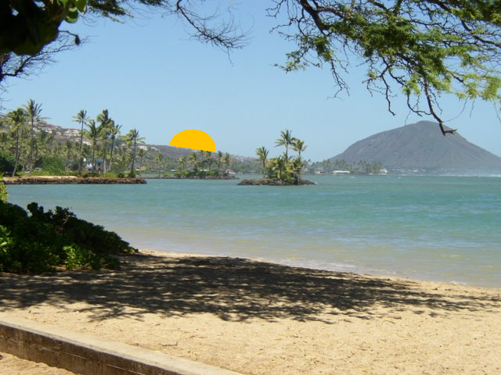



def bullseye(img,x,y,w):

addArcFilled(img,x,y,w,w,0,360,makeColor(255,0,0))

addArcFilled(img,x+w/4,y+w/4,w/2+1,w/2+1,0,360,makeColor(0,255,0))

addArcFilled(img,x+w/3+1,y+w/3+1,w/3+1,w/3+1,0,360,makeColor(255,255,0))

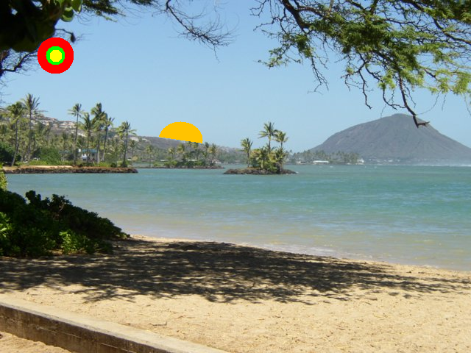



def addHouse(img,x1,y1):

addLine(img, x1+5,y1-5,x1,y1)

addLine(img, x1+5,y1-5,x1+10,y1)

addRectFilled(img,x1,y1,10,12,green)

addRectFilled(img,x1+2,y1+2,2,2,yellow)

addRectFilled(img,x1+6,y1+2,2,2,yellow)

addRectFilled(img,x1+5,y1+6,2,6,red)

def houseLoop(img):

x=y=0

while y<getHeight(img)-1:

while x<getWidth(img)-1:

addHouse(img,x,y)

x=x+15

x=0

y=y+20

explore(img)

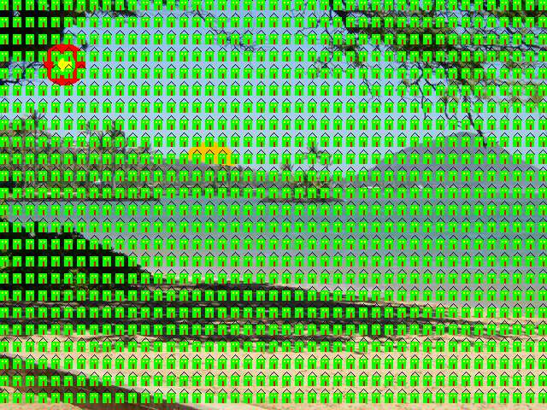



def drawGrid(img,sp):

x=y=0

while(x<getWidth(img)-1):

addLine(img,x,0,x,getHeight(img)-1)

x=x+sp

while(y<getHeight(img)-1):

addLine(img,0,y,getWidth(img)-1,y)

y=y+sp

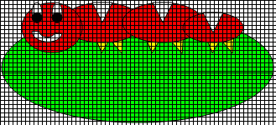



def drawGrid2(img):

sp=5

x=y=0

while(x<getWidth(img)-1):

addLine(img,x,0,x,getHeight(img)-1)

x=x+sp

sp=sp+3

sp=0

while(y<getHeight(img)-1):

addLine(img,0,y,getWidth(img)-1,y)

y=y+sp

sp=sp+3

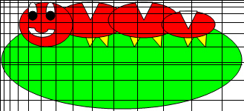



def flip(img):

imgOut = img

for px in getPixels(img):

if(getX(px) in range(0,getWidth(img)-1) and getY(px) in range(0,getHeight(img)-1)):

setColor(getPixelAt(imgOut,getWidth(img)-getX(px)-1+0,getY(px)),getColor(px))

return imgOut

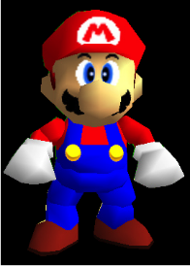 <- Before 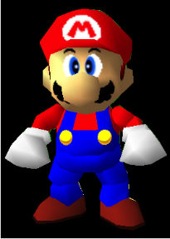 <- After



def mirror20(img):

imgOut = img

for px in getPixels(img):

if(getX(px) in range(0,20) and getY(px) in range(0,getHeight(img)-1)):

setColor(getPixelAt(imgOut,20-getX(px)+20,getY(px)),getColor(px))

return imgOut

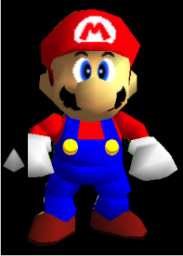



def scaleDown(img):

xOld = yOld = xNew = yNew = 0

newimg = makeEmptyPicture(getWidth(img)/2, getHeight(img)/2)

while(true):

px1 = getPixel(img, xOld,yOld)

px2 = getPixel(img, xOld+1,yOld)

px3 = getPixel(img, xOld,yOld+1)

px4 = getPixel(img, xOld+1,yOld+1)

r = (getRed(px1) + getRed(px2) + getRed(px3) + getRed(px4))/4

g = (getGreen(px1) + getGreen(px2) + getGreen(px3) + getGreen(px4))/4

b = (getBlue(px1) + getBlue(px2) + getBlue(px3) + getBlue(px4))/4

setColor(getPixel(newimg, xNew, yNew), makeColor(r,g,b))

xOld = xOld+2

if(xOld >= getWidth(img)-1):

xOld = 1

yOld = yOld+2

xNew = xNew+1

if(xNew >= getWidth(newimg)-1):

xNew=0

yNew=yNew+1

if(yOld >= getHeight(img) or yNew >=getHeight(newimg)):

break

return newimg



def scaleUp(img):

xOld = yOld = xNew = yNew = 0

newimg = makeEmptyPicture(getWidth(img)\*2, getHeight(img)\*2)

while(true):

px0 = getPixel(img, xOld,yOld)

px1 = getPixel(newimg, xNew,yNew)

px2 = getPixel(newimg, xNew+1,yNew)

px3 = getPixel(newimg, xNew,yNew+1)

px4 = getPixel(newimg, xNew+1,yNew+1)

r = getRed(px0)

g = getGreen(px0)

b = getBlue(px0)

setColor(px1, makeColor(r,g,b))

setColor(px2, makeColor(r,g,b))

setColor(px3, makeColor(r,g,b))

setColor(px4, makeColor(r,g,b))

xNew = xNew+2

if(xNew >= getWidth(newimg)-1):

xNew = 1

yNew = yNew+2

xOld = xOld+1

if(xOld >= getWidth(img)-1):

xOld=0

yOld=yOld+1

if(yNew >= getHeight(newimg) or yOld >=getHeight(img)):

break

return newimg

Original Size:



Scaled down:



Scaled up:

